Test Case: tc006_SPX_Dev5_Crear_Requisicion_Spot_Tipo_Cobro_Proyect_Urgent
Step 1 - Enter username and password and click to button Enter: Credentials Entered
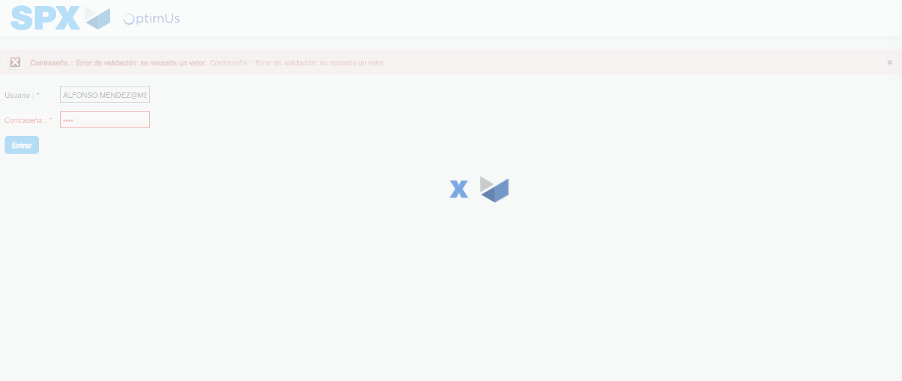Image file-name: QC_Testing-tc006_SPX_Dev5_Crear_Requisicion_Spot_Tipo_Cobro_Proyect_Urgent-1783379954437

Step 2 - Select to UEN and Access to Spot Buy Requisitions : UEN Correctly selected and Correct access
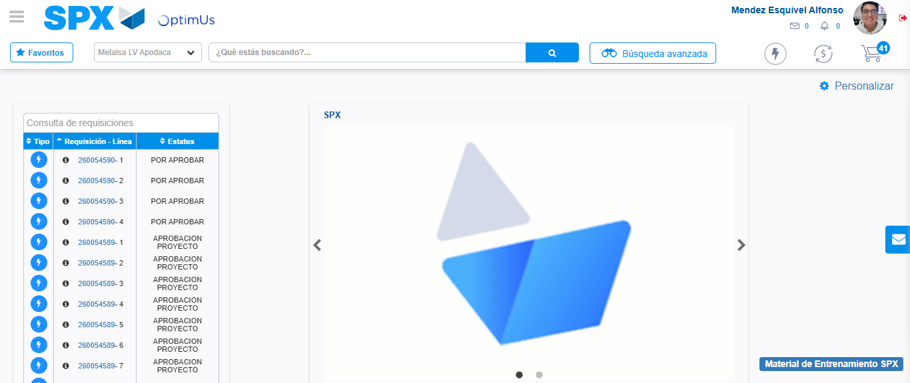Image file-name: QC_Testing-tc006_SPX_Dev5_Crear_Requisicion_Spot_Tipo_Cobro_Proyect_Urgent-1783379979658

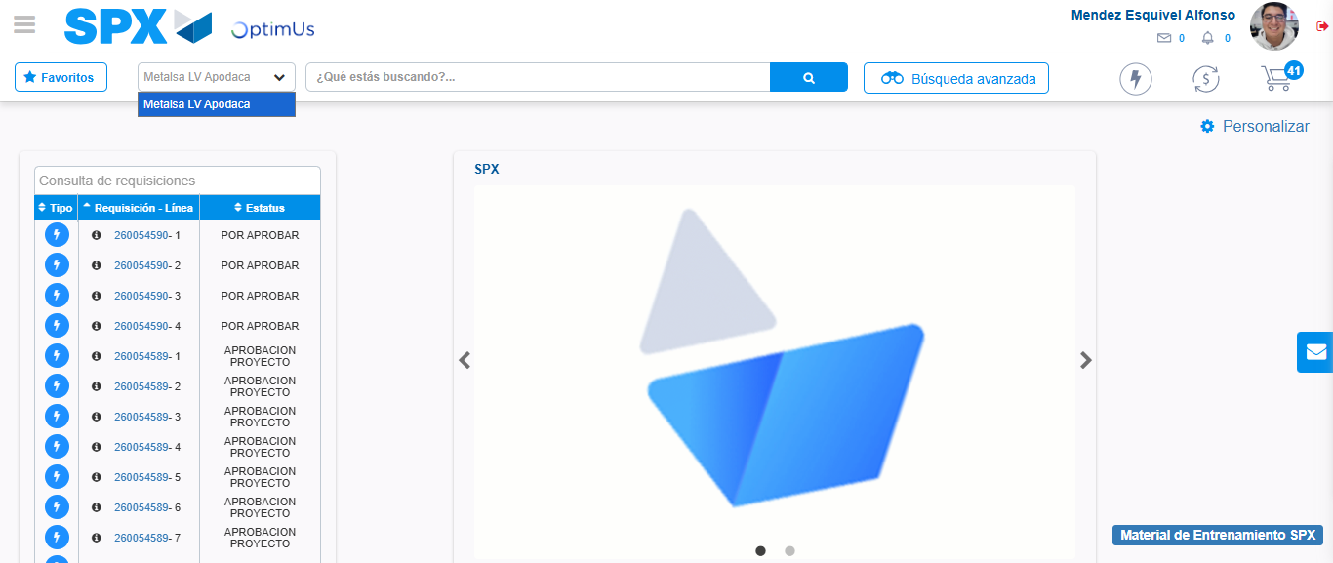Image file-name: QC_Testing-tc006_SPX_Dev5_Crear_Requisicion_Spot_Tipo_Cobro_Proyect_Urgent-1783379982146

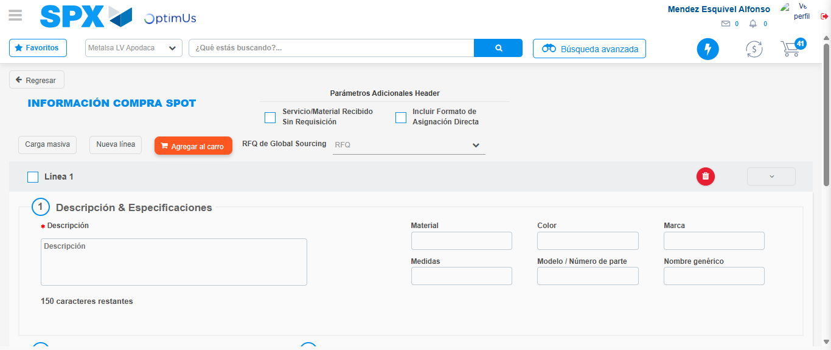Image file-name: QC_Testing-tc006_SPX_Dev5_Crear_Requisicion_Spot_Tipo_Cobro_Proyect_Urgent-1783380004384

Step 3 - Data Capture Spot Buy Requisition: Data captured correctly
Image file-name: QC_Testing-tc006_SPX_Dev5_Crear_Requisicion_Spot_Tipo_Cobro_Proyect_Urgent-1783380004635

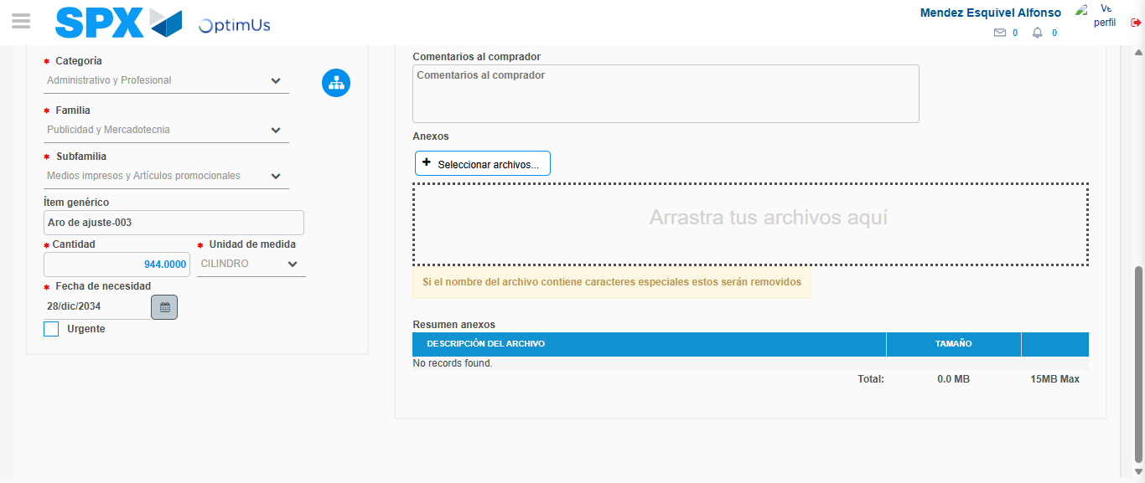Image file-name: QC_Testing-tc006_SPX_Dev5_Crear_Requisicion_Spot_Tipo_Cobro_Proyect_Urgent-1783380014212

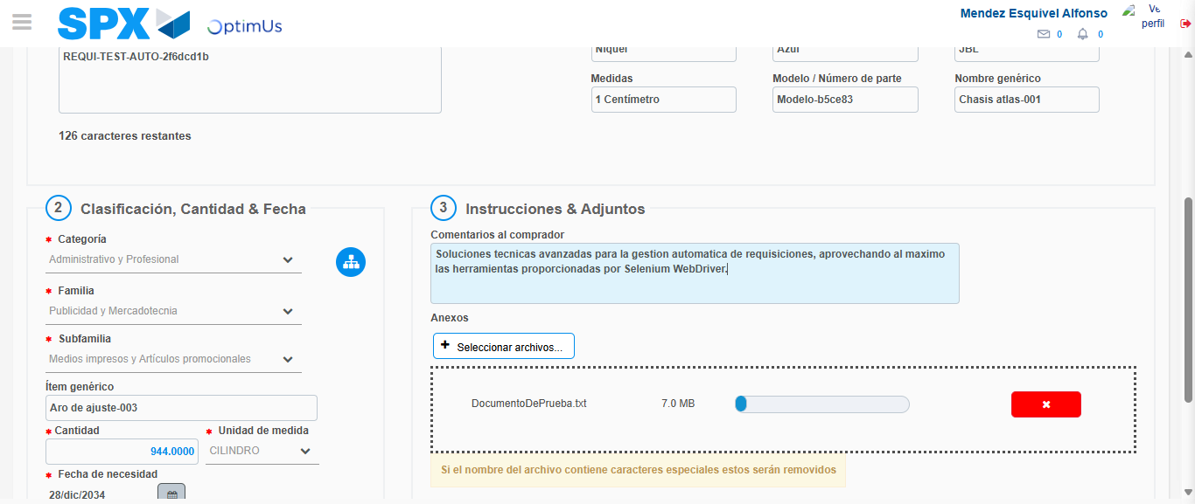Image file-name: QC_Testing-tc006_SPX_Dev5_Crear_Requisicion_Spot_Tipo_Cobro_Proyect_Urgent-1783380014919

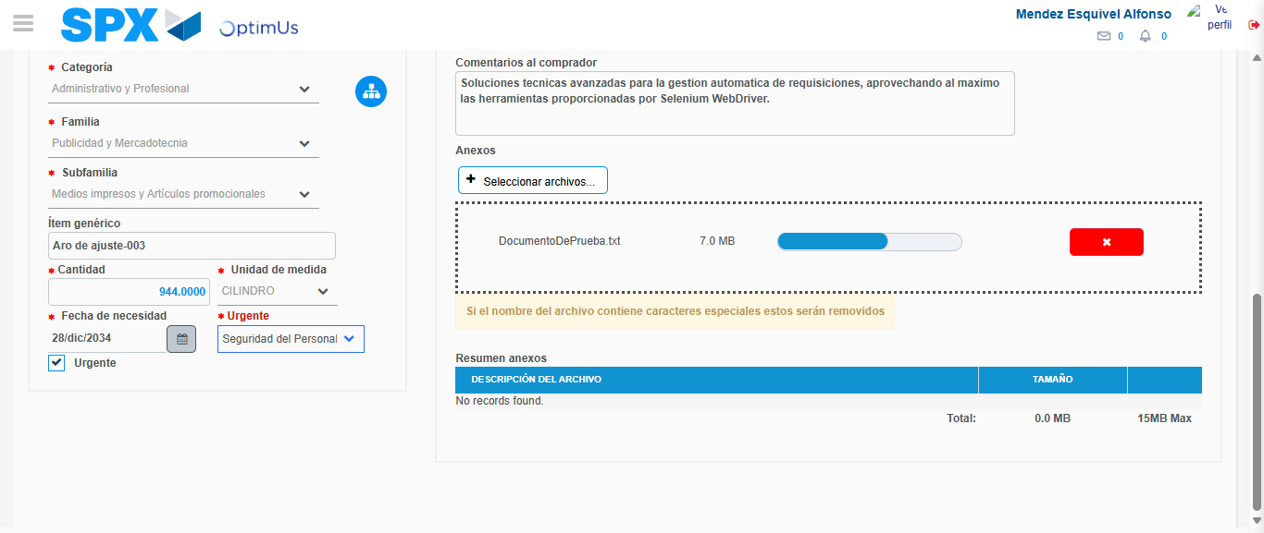Image file-name: QC_Testing-tc006_SPX_Dev5_Crear_Requisicion_Spot_Tipo_Cobro_Proyect_Urgent-1783380018550

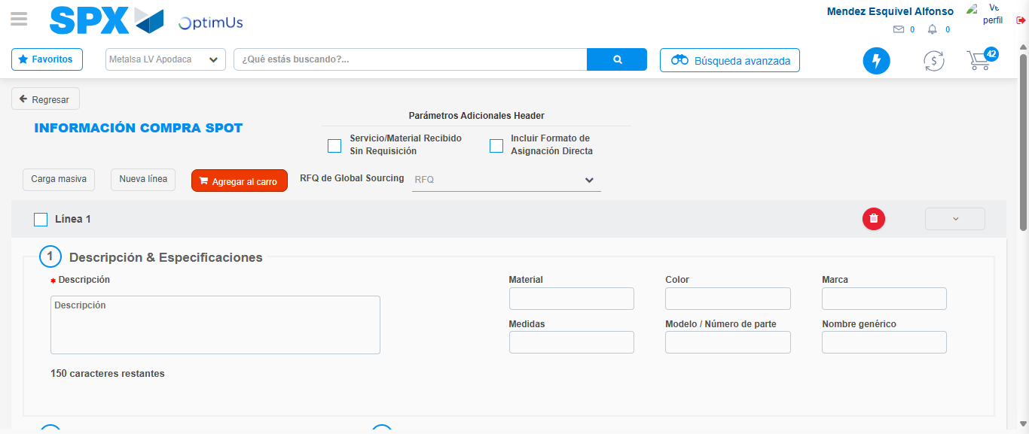Image file-name: QC_Testing-tc006_SPX_Dev5_Crear_Requisicion_Spot_Tipo_Cobro_Proyect_Urgent-1783380025507

Step 7 - Return to Main Page SPX : Return to Main Page SPX
Image file-name: QC_Testing-tc006_SPX_Dev5_Crear_Requisicion_Spot_Tipo_Cobro_Proyect_Urgent-1783379979658

Image file-name: QC_Testing-tc006_SPX_Dev5_Crear_Requisicion_Spot_Tipo_Cobro_Proyect_Urgent-1783379982146

Image file-name: QC_Testing-tc006_SPX_Dev5_Crear_Requisicion_Spot_Tipo_Cobro_Proyect_Urgent-1783380004384

Image file-name: QC_Testing-tc006_SPX_Dev5_Crear_Requisicion_Spot_Tipo_Cobro_Proyect_Urgent-1783380027724

Image file-name: QC_Testing-tc006_SPX_Dev5_Crear_Requisicion_Spot_Tipo_Cobro_Proyect_Urgent-1783380027871

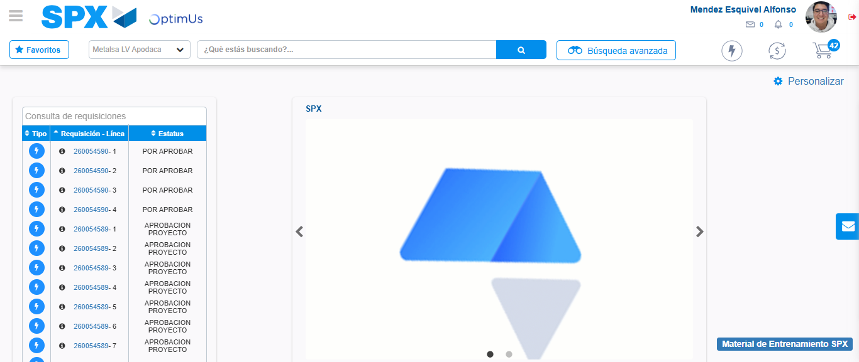Image file-name: QC_Testing-tc006_SPX_Dev5_Crear_Requisicion_Spot_Tipo_Cobro_Proyect_Urgent-1783380048922

Step 8 - Log Out : Log Out SPX
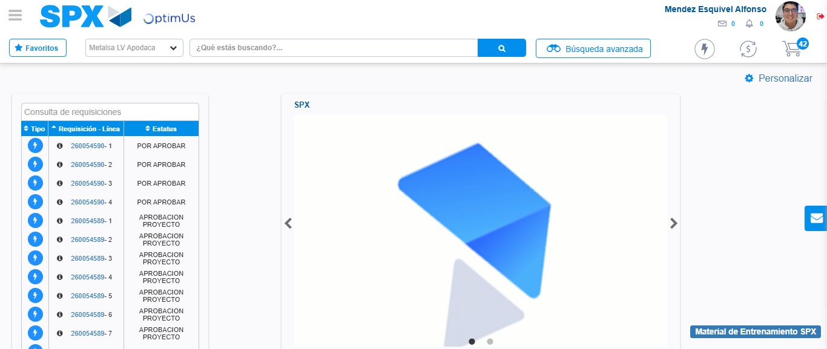Image file-name: QC_Testing-tc006_SPX_Dev5_Crear_Requisicion_Spot_Tipo_Cobro_Proyect_Urgent-1783380049133

